Lab - 4: Convolution

Objectives:
Familiarizing students with the implementation of LTI systems in MATLAB

Lab Tasks:
1. Suppose that a linear time-invariant system is described by impulse response ℎ[𝑛] = 2𝑛 ∗ 𝑢[𝑛]. Compute response of the system to the input signal 𝑥[𝑛] = 𝑢[𝑛 + 10] − 𝑢[𝑛 − 5] for 𝑛 = −15: 15.
Hint: (𝑢[𝑛] is the unit step function. Use the ‘conv’ function for computing the convolution of the given signals and use subplot() command to plot 𝑥[𝑛], ℎ[𝑛] and 𝑦[𝑛].
CODE
n = -15:15; % Define the range of n from -15 to 15

% Define the input signal x[n] = u[n+10] - u[n-5]
x = (n >= -10) - (n >= 5); % Create x[n] using unit step logic

% Define the impulse response h[n] = 2^n * u[n]
h = (n >= 0) .* (2.^n); % Create h[n] using the step and exponent

% Perform convolution using the conv function
y = conv(x, h, 'same'); % Convolve and keep the output the same length

% Plot x[n], h[n], and y[n]
figure;

% Plot x[n]
subplot(3, 1, 1);
stem(n, x, 'b','LineWidth',2);
title('x[n] = u[n+10] - u[n-5]');
xlabel('n');
ylabel('x[n]');

% Plot h[n]
subplot(3, 1, 2);
stem(n, h, 'r','LineWidth',2);
title('h[n] = 2^n * u[n]');
xlabel('n');
ylabel('h[n]');

% Plot y[n]
subplot(3, 1, 3);
stem(n, y, 'k','LineWidth',2);
title('y[n] = x[n] * h[n]');
xlabel('n');
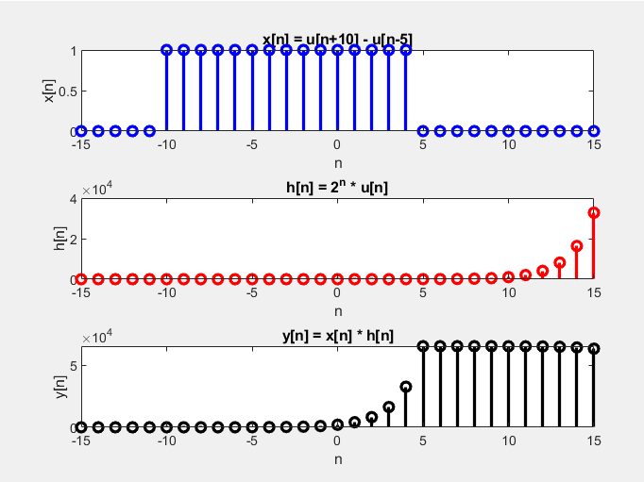
ylabel('y[n]');

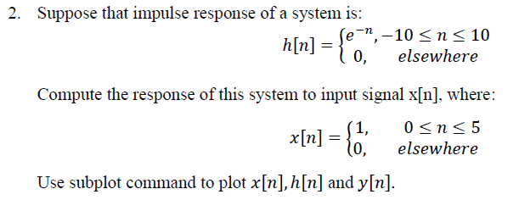
CODE
n = -20:20; % Define the range of n from -20 to 20
N = length(n); % Length of n

% Define h[n] = exp(-n) for n between -10 and 10
h = (n >= -10 & n <= 10) .* exp(-n); % Using logical indexing and exp

% Define x[n] = 1 for 0 <= n <= 5, otherwise 0
x = (n >= 0 & n <= 5); % Using logical indexing

% Perform the convolution of x[n] and h[n]
y = conv(x, h, 'same'); % Convolution using 'same' for length consistency

% Plot x[n], h[n], and y[n]
figure;

% Plot x[n]
subplot(3, 1, 1);
stem(n, x, 'b','LineWidth',2);
title('x[n]');
xlabel('n');
ylabel('x[n]');

% Plot h[n]
subplot(3, 1, 2);
stem(n, h, 'r','LineWidth',2);
title('h[n]');
xlabel('n');
ylabel('h[n]');

% Plot y[n]
subplot(3, 1, 3);
stem(n, y, 'k','LineWidth',2);
title('y[n]');
xlabel('n');
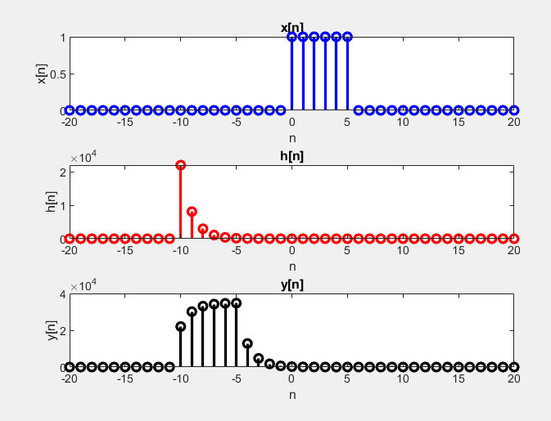
ylabel('y[n]');

3. Consider the following input signal and the impulse response of the LTI system:
𝑥[𝑛] = 𝑒−2𝑛𝑢[𝑛]
ℎ[𝑛] = 𝑢[𝑛 − 10]
Find the output y[n] when n=-15:15. Use subplot command to plot 𝑥[𝑛], ℎ[𝑛] and 𝑦[𝑛].
CODE
n = -15:15; % Define the range of n from -15 to 15
N = length(n); % Length of the sequence

% Define x[n] = e^(-2n) * u[n] where u[n] is the unit step function
x = (n >= 0) .* exp(-2*n); % Logical indexing for u[n] and element-wise exp

% Define h[n] = u[n - 10]
h = (n >= 10); % Logical indexing for u[n - 10]

% Perform convolution of x[n] and h[n]
y = conv(x, h, 'same'); % Convolution with 'same' to match length of n

% Plot x[n], h[n], and y[n]
figure;

% Plot x[n]
subplot(3,1,1); % First subplot
stem(n, x, 'b','LineWidth',2);
title('x[n] = e^{-2n} * u[n]');
xlabel('n');
ylabel('x[n]');

% Plot h[n]
subplot(3,1,2); % Second subplot
stem(n, h, 'r','LineWidth',2);
title('h[n] = u[n - 10]');
xlabel('n');
ylabel('h[n]');

% Plot y[n]
subplot(3,1,3); % Third subplot
stem(n, y, 'k','LineWidth',2);
title('y[n] = x[n] * h[n]');
xlabel('n');
ylabel('y[n]');

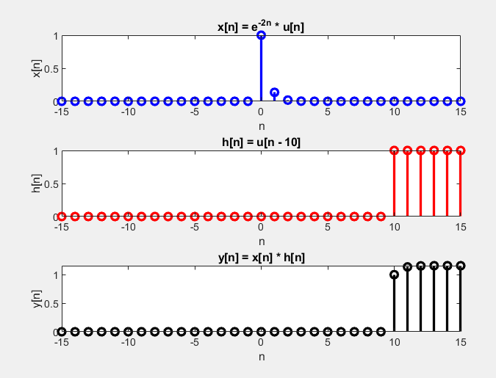
4. Verify all the mathematical properties of convolution integral for the following signals:
𝑥[𝑛] = 𝑒−2𝑛 ∗ 𝑢[𝑛 − 10]
ℎ1[𝑛] = 2−𝑛 ∗ 𝑢[𝑛 + 3]
ℎ2[𝑛] = 0.3𝑛 ∗ 𝑢[𝑛 − 5]
Use subplot command to plot 𝑥[𝑛], ℎ1[𝑛], ℎ2[𝑛], LHS and RHS results of each property.
CODE
n = -15:15; % Define the range of n from -15 to 15
N = length(n); % Length of the sequence

% Define Unit Step Functions using logical indexing
u1 = (n >= 10); % u[n-10] = 1 for n >= 10, otherwise 0
u2 = (n >= -3); % u[n+3] = 1 for n >= -3, otherwise 0
u3 = (n >= 5); % u[n-5] = 1 for n >= 5, otherwise 0

% Define input signal x[n] = e^(-2n) * u[n-10]
x = exp(-2 * n) .* u1; % Pointwise multiplication

% Define impulse responses
h1 = 2.^(-n) .* u2; % h1[n] = 2^(-n) * u[n+3]
h2 = 0.3.^n .* u3; % h2[n] = 0.3^n * u[n-5]

% Plot x[n], h1[n], and h2[n]
figure;

subplot(3,1,1);
stem(n, x, 'b');
title('x[n] = e^{-2n} * u[n-10]');
xlabel('n');
ylabel('x[n]');

subplot(3,1,2);
stem(n, h1, 'r');
title('h1[n] = 2^{-n} * u[n+3]');
xlabel('n');
ylabel('h1[n]');

subplot(3,1,3);
stem(n, h2, 'g');
title('h2[n] = 0.3^n * u[n-5]');
xlabel('n');
ylabel('h2[n]');

% Perform convolution for various properties

% Commutative Property: x[n] * h1[n] = h1[n] * x[n]
a1 = conv(x, h1, 'same');
a2 = conv(h1, x, 'same');

% Associative Property: x[n] * (h1[n] * h2[n]) = (x[n] * h1[n]) * h2[n]
b1 = conv(x, conv(h1, h2, 'same'), 'same');
b2 = conv(conv(x, h1, 'same'), h2, 'same');

% Distributive Property: x[n] * (h1[n] + h2[n]) = (x[n] * h1[n]) + (x[n] * h2[n])
c1 = conv(x, h1 + h2, 'same');
c2 = conv(x, h1, 'same') + conv(x, h2, 'same');

% Plot the results of the properties

figure;

% Commutative Property
subplot(3,2,1);
stem(n, a1, 'b');
title('x[n] * h1[n]');
xlabel('n');
ylabel('a1[n]');

subplot(3,2,2);
stem(n, a2, 'r');
title('h1[n] * x[n]');
xlabel('n');
ylabel('a2[n]');

% Associative Property
subplot(3,2,3);
stem(n, b1, 'g');
title('x[n] * (h1[n] * h2[n])');
xlabel('n');
ylabel('b1[n]');

subplot(3,2,4);
stem(n, b2, 'm');
title('(x[n] * h1[n]) * h2[n]');
xlabel('n');
ylabel('b2[n]');

% Distributive Property
subplot(3,2,5);
stem(n, c1, 'c');
title('x[n] * (h1[n] + h2[n])');
xlabel('n');
ylabel('c1[n]');

subplot(3,2,6);
stem(n, c2, 'y');
title('(x[n] * h1[n]) + (x[n] * h2[n])');
xlabel('n');
ylabel('c2[n]');
